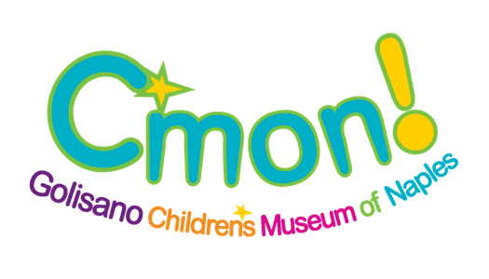
Visitor Experience Specialist

Summary: The Visitor Experience Specialist will be responsible for engaging with visitors throughout the Museum to ensure a quality visitor experience for children and adults. The duties of this position include working inside the exhibits, facilitating daily programs.

This is a hourly part-time position approximately 10-25 hours per week. This position includes weekends and holidays. And requires at least one weekend day of work availability.

Reports to: Visitor Experience Manager

Major Duties

Visitor Engagement and Museum Store and/or Front Desk

- Greets and engages with visitors in a welcoming, energetic, friendly and professional manner
- Dynamically interacts with visitors and exhibits positive energy while circulating in an assigned area
- Answers visitor’s questions or refers them to the appropriate staff member
- Handles difficult situations in a professional manner and communicates with appropriate staff
- Communicates any customer issues to the Manager on Duty for immediate attention and resolution
- Ability to understand, follow and stay current on museum procedures, policies and events
- Maintains museum floor and exhibits, including light housekeeping duties in the exhibits to ensure they are clean
- Ensure all exhibits are full of consumables and in good condition at the beginning of each day including constantly resetting exhibits throughout the day
- Assists with the daily cleaning/sanitizing and oversees the daily switch of all exhibit loose parts
- Ensures all exhibits are sanitized and reset properly each night at closing
- Assists with covering breaks for Guest Services Specialists
- Assists with general crowd control and provides visitors with directions and advice on areas to visit in the museum
- Works at least one after-hours event every other month
- Must be able to work the Museum Store fluently and proficiently o Processes sales through POS at the Museum Store
  - Restocks items in assigned areas as needed during each assigned shift and communicates any inventory needs to the Visitor Experience Manager or Museum Store Coordinator
- May assist with training other Guest Services Specialists • Cover basic POS stations in the event of open shifts or call outs • Must be able to perform the duties of the Front Desk:
  - Processes daily admission sales, museum memberships and payments for workshops, events or fee based activities
- Provides information to the visitors regarding tours, classes, workshops, events and other programs or activities
- Light janitorial duties as needed or assigned
Revised 3/11/2021 Guest Services Specialist – Golisano Children’s Museum of Naples 1 of 2
15080 Livingston Road, Naples, FL 34109 www.cmon.org

General Qualifications

- Must be at least 15 years of age
- Must be reliable and report to scheduled shifts on time
- Have energy, enthusiasm, positive team attitude and prior experience working with children and/or POS stations
- Must be outgoing, self-motivated and enjoy working with visitors and people of all ages
- Must be able to work a flexible schedule including weekends and holidays
- Knowledge of data entry and ticketing/point of sale software is helpful
- Ability to work well with others and visitors, maintaining a professional manner using tact, initiative, good judgement and confidentiality
- Ability to react appropriately in a fast-paced environment and work independently with little supervision • Ability to multitask and prioritize duties
- Excellent organizational skills, and oral and written communication skills
- Ability to bend, kneel and lift up to 35 pounds
- Ability to stand and walk around for extended periods of time (4-hour shifts)
- Bilingual not required but appreciated
- Must be fingerprinted and pass a background check. Employment is contingent upon results of background check.

The above is intended to describe the general content of and requirements for the performance of this job. It is not to be construed as an exhaustive statement of duties, responsibilities or requirements.

To Apply:
Please send cover letter, resume, three references and a completed job application to: hrjobs@cmon.org or mail to: HR Jobs 15080 Livingston Road, Naples, FL 34109

No phone calls please
C’mon is an Equal Opportunity Employer (EOE) in compliance with all Federal, Florida State and local ordinances, including Title VII of the Civil Rights Act of 1964, the Age Discrimination in Employment Act of 1967, the Vietnam Era Veterans Readjustment Assistance Act of 1974, the Americans with Disabilities Act of 1990, and the Genetic Information Nondiscrimination Act of 2008.
Revised 3/11/2021 Guest Services Specialist – Golisano Children’s Museum of Naples 2 of 2
15080 Livingston Road, Naples, FL 34109 www.cmon.org

